**Workflows Application BMJ**

The purpose of the application is to facilitate the work of BMJ employees, especially in terms of saving time, but also to keep an eye on the progress and evolution of work on the job sites. The application is also done in part for the customer so that he has more visibility and transparency regarding the evolutions of the sites.

The application must include 5 types of users:

-The Managers

-The Workers

-The Delivery guys

-The Customers

-The Direction

Each type of user should have their username and password in order to access the space that is appropriate for them. Obviously, each space will be different depending on the type of user. In other words, the space dedicated to workers will be different from that of the manager or the direction. These lasts will have information, functionalities and accesses that others may not have.

**1)The space/area dedicated to the Managers**

**-The manager must be able to create a list of worksites and assign the number of workers and delivery workers he wants to a worksite, where he will also include the customer concerned by the worksite.**

-The worksheets for each customer and project must be integrated into the Managers’ area.

For Example:

|  |  |  |  |  |  |  |  |
| --- | --- | --- | --- | --- | --- | --- | --- |
| **Nom de l'entreprise:** | | | |  | | --- | | **DATE: / /** | | | | | |
|
| **ADRESSE DU CHANTIER** | | | **Etage/Coté/PAV** | **No Cde prestaire** | | **No de logement** |
|  | | |  |  | |  |
|
|  | | |  |  | |  |
| **PIECES** | **SOLS** | | | | |  |
| **NOVIBAT** | | **MODUL'UP** | | |  |
| Dimensions hors chutes | | Dimensions hors chutes | | |  |
| **ENTREE** |  | |  | | |  |
|  |
|  |
| **DEGAGEMENT** |  | |  | | |  |
|  |
|  |
| **SEJOUR CHAMBRE INCORPOREE** |  | |  | | |  |
|  |
|  |
|  |
|  |
| **CHAMBRE 1** |  | |  | | |  |
|  |
| **CHAMBRE 2** |  | |  | | |  |
|  |
| **CHAMBRE 3** |  | |  | | |  |
|  |
| **CHAMBRE 4** |  | |  | | |  |
|  |
| **CELLIER/ PIECE  NOIRE** |  | |  | | |  |
|  |
|  |
|  |
| **CUISINE** |  | |  | | |  |
|  |
| **SALLE DE BAIN** |  | |  | | |  |
|  |
| **CABINET DE TOILETTE** |  | |  | | |  |
|  |
| **WC** |  | |  | | |  |
|  |
| **plinthe bois** | | **REVETEMENT MURAL** | **BARRE DE SEUIL** | | **BUTEE DE SOL** | |
| **5 cm** |  |  | **percée** |  | **caoutchouc** |  |
|  |
| **10 cm** |  | **adhésif** |  | **balustre** |  |
|
|  |
| **Ragréage 1 sac / 5m² (hors chutes)** | | **PLAN** | | | | |
|  | |  | | | | |
|
| **SILICONE sanitaire blanc** |  |
|
|  |
| **A préparer pour le: (env.24h)** |  |  | | | | |
|  |  |  | | | | |
|  |  |  | | | | |
| **Visa service EDL** |  |  | | | | |

-The application must also have access to the camera so that manager can take a photo of the site to either show its evolution or show something important that requires special intervention. In addition to the access to the camera, there must be a device to make comments on the photos or modifications (to be able to draw lines or circles on the photo to show something precise on it for example).

-The manager must have access to the stopwatch of the site in order to check whether the forecast time dedicated to the site is well respected or not.

-They must also be provided with work orders (without price, etc.)

EX:

|  |  |  |  |
| --- | --- | --- | --- |
| LE FOYER REMOIS PAGE N° 1 | | | |
| **NOM ET ADRESSE DE L'EXPÉDITEUR** | | BON DE TRAVAUX N° 2020 7936 | |
| LE FOYER REMOIS | |
| SIEGE LE FOYER REMOIS | |
|  | |
| 8 rue Lanson - CS 10029 | |  | |
| 51722 REIMS CEDEX | |  | |
| Tél : 03 26 84 46 46 Fax : 03 26 49 01 58 | | BMJ | |
| Rcs : 335581211 REIMS B Siret : 335 581 211 00026 | |  | |
| No Intracommunautaire FR45335581211 | | 5 RUE MARIE-DOMINIQUE MAINGOT | |
| **Réf. Fournisseur** F / 20091  **Marché N°** | | 51100 REIMS | |
| **Provenance**  **Objet** GENERE PAR LES EDL - EUR | |  | |
| **SERVICE** ETATS DES LIEUX | | **ÉMETTEUR** BOGENEZ Frédéric | |
| **LOCALISATION** |  | **ADRESSE** | **MME, M. LARMIGNY / MANDON** |
| **Programme** 1001 CHEMIN VERT | | **4 ALLEE DE LA FAUVETTE** | |
| **Tranche** T1 **Ensemble** 922 **Escalier** 02 **Étage** RDC | | **51100 REIMS** | |
| **Logement** 323 **Module** 1001L0323 | | **Tél. professionnel** 0662864387 | |
|  | | **Tél. mobile** 0642643671 | |
| **EDL n ° 2020/1547** | |  | |

|  |
| --- |
| **DÉLAI D'EXÉCUTION** 12 **JOURS PÉRIODE DU** 20-07-2020 **AU** 31-07-2020 |

|  |  |  |  |
| --- | --- | --- | --- |
| **ARTICLE DÉSIGNATION UNITÉ QUANTITÉ** | **PRIX** | **UNITAIRE H.T.** | **TOTAL T.T.C.** |
| **CHAMBRE 1** |  | |  |
| 2PE00003 REFECTION PEINTURE SATIN 1 COUCHE M2 34,00 | 5,93 | | 241,74 |
| Blanchir murs Avant pose papier peint par nouveau locataire ,zone sous le |  | |  |
| champlat. |  | |  |
| **CHAMBRE 2** |  | |  |
| 2MURPP POSE CHAMPLAT TOUS TYPES ML 13,00 | 5,93 | | 92,43 |
| Dans le prolongement de l'existant. |  | |  |
| 2PE00003 REFECTION PEINTURE SATIN 1 COUCHE M2 40,00 | 5,93 | | 284,40 |
| Blanchir murs Avant pose papier peint par nouveau locataire. Partie basse sous |  | |  |
| champlat. |  | |  |
| 2PE00004 REFECTION PEINTURE SATIN 2 COUCHES M2 1,00 | 7,82 | | 9,39 |
| Mise en peinture nouveau champlat. |  | |  |
| **CUISINE** |  | |  |
| 2PE00002 COUCHE IMPRESSION M2 2,00 | 4,03 | | 9,67 |
| Porte paliere et huisserie. |  | |  |
| 2PE00004 REFECTION PEINTURE SATIN 2 COUCHES M2 2,00 | 7,82 | | 18,77 |
| Porte paliere et huisserie. |  | |  |
| 2PE0002 LESSIVAGE PEINTURE M2 2,00 | 2,37 | | 5,69 |
| Porte paliere et huisserie. |  | |  |
| 2RSOL20 REMPLACER BARRE DE SEUIL TOUS TYPES U 2,00 | 5,93 | | 14,22 |
| 2RSOL31 POSE BUTEE DE SOL OU BALUSTRE U 3,00 | 1,90 | | 6,83 |
| **MONTÉE ESCALIER 1** |  | |  |
| 2PE00019 PEINTURE SPECIALE SOL 2 COUCHES M2 7,00 | 7,82 | | 65,70 |
| Sur marches escaliers |  | |  |
| Suite de la description des travaux page 2 |  | |  |
| ORIGINAL À CONSERVER PAR LE DESTINATAIRE | | | |

|  |  |  |  |
| --- | --- | --- | --- |
| LE FOYER REMOIS | | | PAGE N° 2 |
| **TRAVAUX A EFFECTUER** | | BON DE TRAVAUX N° 2020 7936 | |
| **ARTICLE** | **DÉSIGNATION** | **UNITÉ QUANTITÉ PRIX UNITAIRE H.T. TOTAL T.T.C.** | |
| **SALLE DE BAIN** | |  | |
| 2FAIE09 | NETTOYAGE ET DECAPAGE FAIENCE | M2 5,00 2,37 14,22 | |
| **SEJOUR** | |  | |
| 2PE00002 | COUCHE IMPRESSION | M2 4,00 4,03 19,34 | |
| Porte paliere et porte escaliers et huisseries. | |  | |
| 2PE00004 | REFECTION PEINTURE SATIN 2 COUCHES | M2 4,00 7,82 37,54 | |
| Porte paliere et porte escaliers et huisseries. | |  | |
| 2PE0002 | LESSIVAGE PEINTURE | M2 4,00 2,37 11,38 | |
| Porte paliere et porte escaliers et huisseries. | |  | |
| 2RSOL06 | REVETEMENT PLASTIQUE + RAGREAGE | M2 16,00 17,78 341,28 | |
| **WC** | |  | |
| 2RSOL06 | REVETEMENT PLASTIQUE + RAGREAGE | M2 1,00 17,78 21,33 | |
| **TOTAL H.T.** | | 994,93 | |
| **T.V.A.** | 20,00 % | 198,99 | |
| **TOTAL T.T.C.** | | **1.193,92** | |

|  |  |  |  |  |  |
| --- | --- | --- | --- | --- | --- |
| **AFFECTATION BUDGÉTAIRE** | | **CODES STRUCTURE ET SCHÉMA :** E.D.L. | | | |
| **CODE BUDGET** | **RUBRIQUE** |  | **INSTANCES** | **LIBELLÉ DU POSTE BUDGÉTAIRE** | **MONTANT H.T.R.** |
| 1 EDLAR |  | DPA | EDL | TRAVAUX EDL A REPARTIR | 99,49 |
| 1 EDLAR | DPA | EDL | TRAVAUX EDL A REPARTIR | 994,93 |

|  |  |  |  |  |  |  |  |  |  |
| --- | --- | --- | --- | --- | --- | --- | --- | --- | --- |
| **AFFECTATION ANALYTIQUE** | |  | | | | | | | |
| **CODE BUDGET** | **RÉFÉRENCES PATRIMOINE** | | | |  | **RÉFÉRENCES OCCUPANT** | | | **MONTANT H.T.R.** |
| 1 EDLAR | 1001 | T1 | 922 | 02 | 1001L0323 | L | 34335 | LARMIGNY / MANDON | 99,49 |
| 1 EDLAR | 1001 | T1 | 922 | 02 | 1001L0323 | L | 34335 | LARMIGNY / MANDON | 994,93 |

|  |  |  |
| --- | --- | --- |
|  | | **Édité le**  15-07-2020 |
|  | Le Service Émetteur | |
| EXEMPLAIRE À JOINDRE OBLIGATOIREMENT À LA FACTURE | | |

**WARNING!** This is the original work order that the Direction receives, so there are some elements that managers and workers should not have access to. We will therefore surround or block the elements that should not appear in the space of managers and workers:

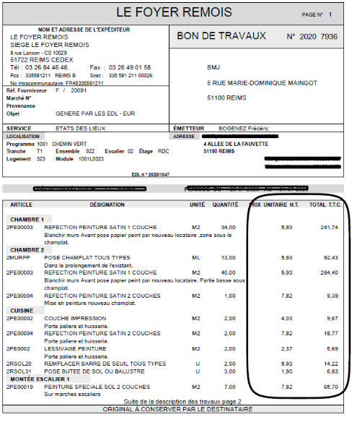

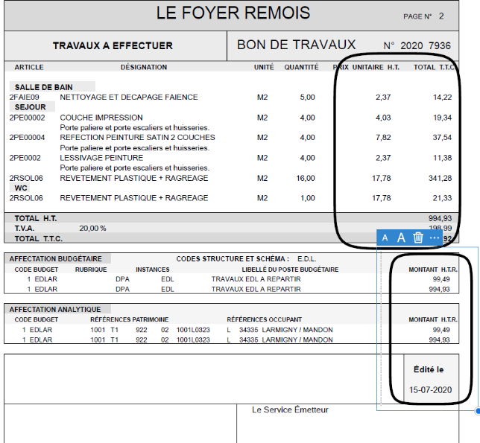

**2)The area/space dedicated to WORKERS**

-To achieve a considerable saving of time, it is necessary to put in place a list of ready tools on a daily basis, where the worker only has to check and specify the quantity to transmit the information to the delivery man who will do what is necessary to deliver the tools on time. The list will have 6 categories: when the worker clicks on one of the categories, a list of equipment that corresponds to that category must be displayed with check boxes.

See the EQUIPMENT LIST (USB).

**-After the selection of the tools, the managers as well as the delivery guys must receive a notification that shows them the details of the tools chosen by the workers.**

-The application must also have access to the camera so that manager can take a photo of the site to either show its evolution or show something important that requires special intervention. In addition to the access to the camera, there must be a device to make comments on the photos or modifications (to be able to draw lines or circles on the photo to show something precise on it for example).

**-**Finally, it is necessary to create an option to set up the time of change, that is to say the arrival time of the workers on the site and the time of the end of the work, knowing that they work in general from 8 am to 12 pm and from 1 pm to 6pm. We would like these hours of work to be cut in 30 min increments and the workers to be able to specify within 30 minutes the time of change, knowing that they already have a precise number of hours to finish their job on a worksite. (SCORING SYSTEM)

**3)The area/space dedicated to the Delivery guys**

**-Availability of the Checklist: As soon as the worker completes his list of materials, the delivery man must receive a notification with the checklist containing the tools selected by the worker.**

-Availability of the time of change present in the “workers’ space” because it is the delivery man who takes care of transporting the equipment, after the end of each site, to another site.

- The delivery man must receive notifications regarding the start time of a worksite and the end time. He must also receive a notification if the deadline is not respected.

**-** Availability of the customer equipment list:

|  |  |  |  |  |
| --- | --- | --- | --- | --- |
| **LISTE DES REFERENCES DU MARCHE DE FOURNITURES DE L'ORGANISME** | | | | |
| Référence Foyer Rémois | Référence Fournisseur | Fournisseur | Désignation du produit | Unité |
| 1 |  | TITULAIRE DU MARCHE DE FOURNITURES FOYER REMOIS | Sol Novibat U2SP3 ref: 23662 | M2 |
| 2 |  | Sol MODUL'UP U2SP3 | M2 |
| 3 |  | Nez de Marche | ML |
| 4 |  | Ragréage | U |
| 5 |  | Ragreage fibré | U |
| 6 |  | Rouleau Adhésif MODUL'UP | U |
| 7 |  | Tube soudure MODUL'UP | U |
| 8 |  | Butée Balustre | U |
| 9 |  | Butée de sol | U |
| 10 |  | Plinthe bois hauteur 70mm | ML |
| 11 |  | Plinthe bois hauteur 100mm | ML |
| 12 |  | Plinthe PVC hauteur: 50mm | ML |
| 13 |  | Plinthe PVC hauteur 100mm | ML |
| 14 |  | Cartouche Silicone blanc | U |
| 15 |  | Revêtement Mural ECO junior 5 | ML |
| 16 |  | Revêtement Mural ECO contour | ML |
| 17 |  | Barre Seuil percé 630mm | U |
| 18 |  | Barre Seuil percé 730mm | U |
| 19 |  | Barre Seuil percé 830mm | U |
| 20 |  | Barre Seuil percé 930mm | U |
| 21 |  | Barre Seuil percé 1660mm | U |
| 22 |  | Barre Seuil percé 3350mm | ML |
| 23 |  | Barre Seuil Adhesif 630mm | U |
| 24 |  | Barre Seuil Adhesif 730mm | U |
| 25 |  | Barre Seuil Adhesif 830mm | U |
| 26 |  | Barre Seuil Adhesif 930mm | U |
| 27 |  | Barre seuil Adhesif 3350mm | ML |
| 29 |  | Barre seuil Rattrapage 0,83 | U |
| 30 |  | Barre seuil Rattrapage 0,93 | U |
| 31 |  | Barre seuil Rattrapage 1,66 | U |
| 32 |  | Papier peint 220g | U |
| 33 |  | Papier peint 190g | U |
| 34 |  | Toile Rénovation plafond | U |
| 35 |  | Revetement Mural Intisé a peindre | U |
| 36 |  | Colle Acrylique pour sol | KG |
| 37 |  | Colle Papier (paquet de 250g) | U |
| 38 |  | Papier Peint 180 a 220g | U |
| 39 |  | Baguette angle 20x20 | ML |

**4)The area/space dedicated to The Customers**

**-** The client must have access to the worksite’s evolution (photos).

-Implementation of a messaging system allowing the client to make requests, comments or send documents to the company directly on the application.

**5)The area/space dedicated to The Direction**

-Full access to all areas/spaces of all users.

-The Direction must have at its disposal, in its space, a platform that allows to generate the usernames and passwords of all workers, managers, delivery guys and customers.